Experiment 11

Aim: - To study about IPv6 addressing and subnetting properties.

**IPv6 Adressing**

An **IPv6 address** is represented as eight groups of four hexadecimal digits, each group representing 16 bits (two octets, a group sometimes also called a hextet). The groups are separated by colons (:). An example of an **IPv6 address** is: 2001:0db8:85a3:0000:0000:8a2e:0370:7334.

Here are some of the points which we can make out of IPv6 addressing: -

* **128 bits (or 16 bytes) long:** four times as long as its predecessor.
* **128 bits (or 16 bytes) long:** four times as long as its predecessor.
* **2128** : about 340 billion billion billion billion different addresses.
* Colon separated addresses, 8 groups of four all hexadecimal digits.

**IPv6 Subnetting**

IPv6 addresses use 128 bits to represent an address which includes bits to be used for sub netting. The second half of the address (least significant 64 bits) is always used for hosts only. Therefore, there is no compromise if we subnet the network.

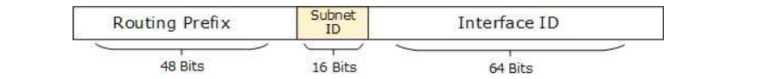

16 bits of subnet is equivalent to IPv4’s Class B Network. Using these subnet bits, an organization can have another 65 thousands of subnets which is by far, more than enough.

Thus routing prefix is /64 and host portion is 64 bits. We can further subnet the network beyond 16 bits of Subnet ID, by borrowing host bits; but it is recommended that 64 bits should always be used for hosts addresses because auto-configuration requires 64 bits.

IPv6 subnetting works on the same concept as Variable Length Subnet Masking in IPv4.

/48 prefix can be allocated to an organization providing it the benefit of having up to /64 subnet prefixes, which is 65535 sub-networks, each having 264 hosts. A /64 prefix can be assigned to a point-to-point connection where there are only two hosts (or IPv6 enabled devices) on a link.

**RESULT**

The IPv6 addressing and subnetting were successfully read and understood.